Exercises

* Reformat the last code to organize the widgets *horizontally* (Hint: lookup *Row*)

**last code**

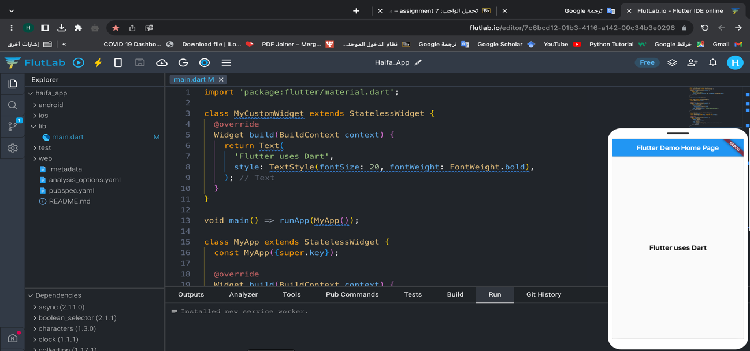

**1:**

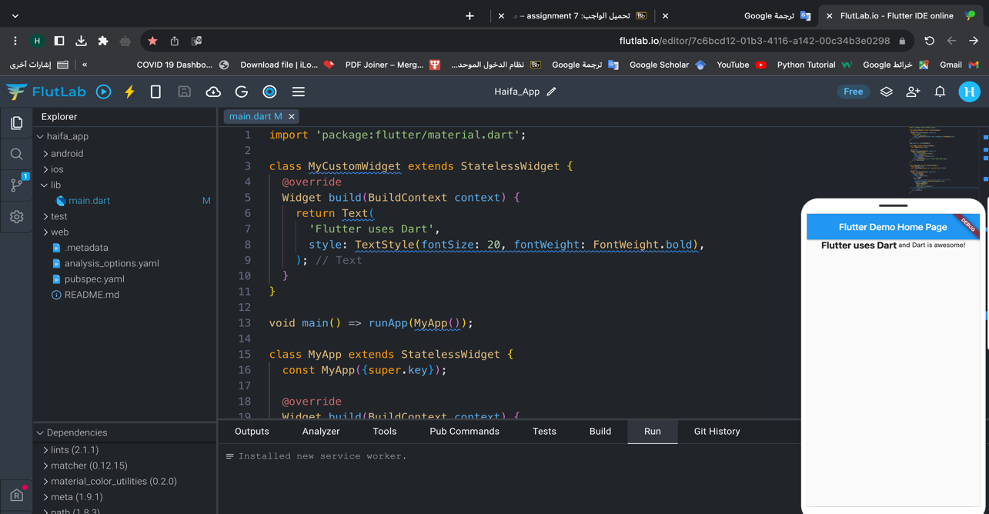

import 'package:flutter/material.dart';

class MyCustomWidget extends StatelessWidget {

@override

Widget build(BuildContext context) {

return Text(

'Flutter uses Dart',

style: TextStyle(fontSize: 20, fontWeight: FontWeight.bold),

);

}

}

void main() => runApp(MyApp());

class MyApp extends StatelessWidget {

const MyApp({super.key});

@override

Widget build(BuildContext context) {

return MaterialApp(

title: 'Flutter Hello World',

theme: ThemeData(

primarySwatch: Colors.blue,

),

home: MyHomePage(title: 'Flutter Demo Home Page'),

);

}

}

class MyHomePage extends StatelessWidget {

final String title;

const MyHomePage({super.key, required this.title});

@override

Widget build(BuildContext context) {

return Scaffold(

appBar: AppBar(

title: Text(title),

),

body: Row(

// Using Row widget to organize widgets horizontally

mainAxisAlignment: MainAxisAlignment.center,

children: <Widget>[

MyCustomWidget(),

Text(' and '),

Text('Dart is awesome!'),

],

),

);

}

}

* Reformat the last code to change the background color of the *Scaffold* to **Red**.

**2:**

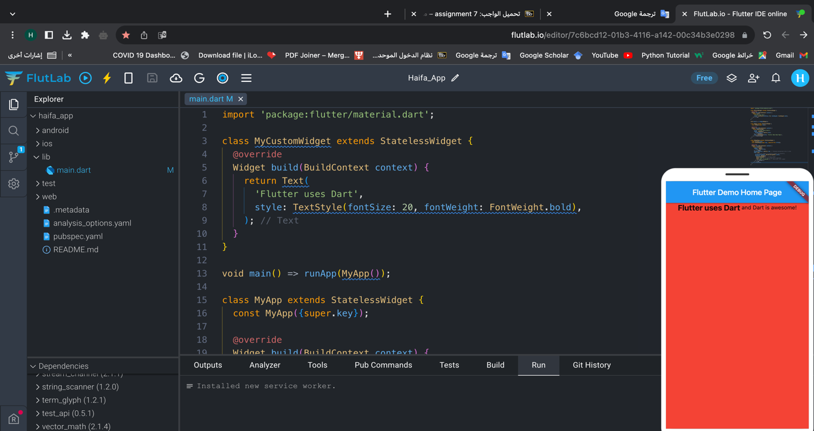

import 'package:flutter/material.dart';

class MyCustomWidget extends StatelessWidget {

@override

Widget build(BuildContext context) {

return Text(

'Flutter uses Dart',

style: TextStyle(fontSize: 20, fontWeight: FontWeight.bold),

);

}

}

void main() => runApp(MyApp());

class MyApp extends StatelessWidget {

const MyApp({super.key});

@override

Widget build(BuildContext context) {

return MaterialApp(

title: 'Flutter Hello World',

theme: ThemeData(

primarySwatch: Colors.blue,

),

home: MyHomePage(title: 'Flutter Demo Home Page'),

);

}

}

class MyHomePage extends StatelessWidget {

final String title;

const MyHomePage({super.key, required this.title});

@override

Widget build(BuildContext context) {

return Scaffold(

appBar: AppBar(

title: Text(title),

),

backgroundColor: Colors.red, // Changing background color to Red

body: Row(

mainAxisAlignment: MainAxisAlignment.center,

children: <Widget>[

MyCustomWidget(),

Text(' and '),

Text('Dart is awesome!'),

],

),

);

}

}

* Reformat the last code to change the *AppBar* color to **Red**.

**3:**

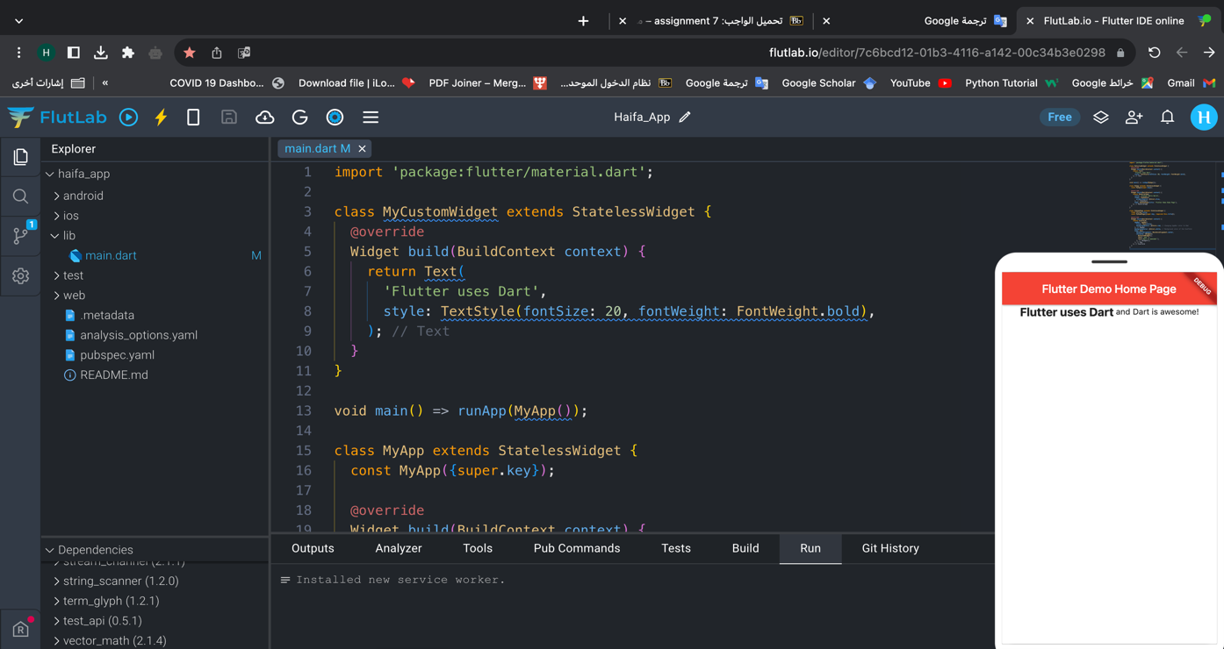

import 'package:flutter/material.dart';

class MyCustomWidget extends StatelessWidget {

@override

Widget build(BuildContext context) {

return Text(

'Flutter uses Dart',

style: TextStyle(fontSize: 20, fontWeight: FontWeight.bold),

);

}

}

void main() => runApp(MyApp());

class MyApp extends StatelessWidget {

const MyApp({super.key});

@override

Widget build(BuildContext context) {

return MaterialApp(

title: 'Flutter Hello World',

theme: ThemeData(

primarySwatch: Colors.blue,

),

home: MyHomePage(title: 'Flutter Demo Home Page'),

);

}

}

class MyHomePage extends StatelessWidget {

final String title;

const MyHomePage({super.key, required this.title});

@override

Widget build(BuildContext context) {

return Scaffold(

appBar: AppBar(

title: Text(title),

backgroundColor: Colors.red, // Changing AppBar color to Red

),

backgroundColor: Colors.white,

body: Row(

mainAxisAlignment: MainAxisAlignment.center,

children: <Widget>[

MyCustomWidget(),

Text(' and '),

Text('Dart is awesome!'),

],

),

);

}

}

* Reformat the last code to change the start and end colors of the gradient effect (Hint: lookup *begin* and *end* in *LinearGradient*)

**4:**

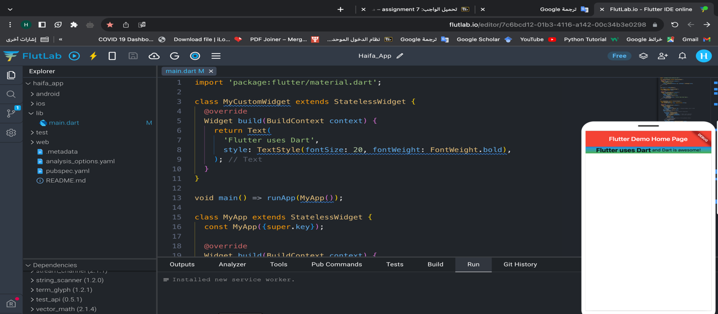

import 'package:flutter/material.dart';

class MyCustomWidget extends StatelessWidget {

@override

Widget build(BuildContext context) {

return Text(

'Flutter uses Dart',

style: TextStyle(fontSize: 20, fontWeight: FontWeight.bold),

);

}

}

void main() => runApp(MyApp());

class MyApp extends StatelessWidget {

const MyApp({super.key});

@override

Widget build(BuildContext context) {

return MaterialApp(

title: 'Flutter Hello World',

theme: ThemeData(

primarySwatch: Colors.blue,

),

home: MyHomePage(title: 'Flutter Demo Home Page'),

);

}

}

class MyHomePage extends StatelessWidget {

final String title;

const MyHomePage({super.key, required this.title});

@override

Widget build(BuildContext context) {

return Scaffold(

appBar: AppBar(

title: Text(title),

backgroundColor: Colors.red, // Changing AppBar color to Red

),

backgroundColor: Colors.white,

body: Container(

// Using Container to apply gradient background

decoration: BoxDecoration(

gradient: LinearGradient(

begin: Alignment.topCenter, // Start color position

end: Alignment.bottomCenter, // End color position

colors: [

Colors.blue,

Colors.green

], // Start and end colors of the gradient effect

),

),

child: Row(

mainAxisAlignment: MainAxisAlignment.center,

children: <Widget>[

MyCustomWidget(),

Text(' and '),

Text('Dart is awesome!'),

],

),

),

);

}

}

* Reformat the last code to create a new widget called *MyButton* that replaces the *ElevatedButton* widget in the code. However, it should accept the *text* as a parameter. Then, use the *MyButton* widget to create two buttons: *Submit* and *Cancel*.

**5:**

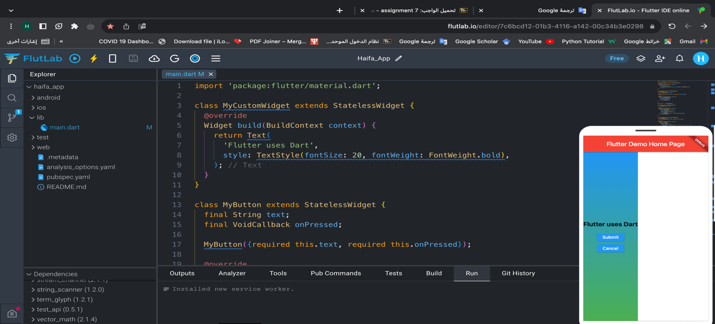

import 'package:flutter/material.dart';

class MyCustomWidget extends StatelessWidget {

@override

Widget build(BuildContext context) {

return Text(

'Flutter uses Dart',

style: TextStyle(fontSize: 20, fontWeight: FontWeight.bold),

);

}

}

class MyButton extends StatelessWidget {

final String text;

final VoidCallback onPressed;

MyButton({required this.text, required this.onPressed});

@override

Widget build(BuildContext context) {

return ElevatedButton(

onPressed: onPressed,

child: Text(text),

);

}

}

void main() => runApp(MyApp());

class MyApp extends StatelessWidget {

const MyApp({super.key});

@override

Widget build(BuildContext context) {

return MaterialApp(

title: 'Flutter Hello World',

theme: ThemeData(

primarySwatch: Colors.blue,

),

home: MyHomePage(title: 'Flutter Demo Home Page'),

);

}

}

class MyHomePage extends StatelessWidget {

final String title;

const MyHomePage({super.key, required this.title});

@override

Widget build(BuildContext context) {

return Scaffold(

appBar: AppBar(

title: Text(title),

backgroundColor: Colors.red, // Changing AppBar color to Red

),

backgroundColor: Colors.white,

body: Container(

decoration: BoxDecoration(

gradient: LinearGradient(

begin: Alignment.topCenter,

end: Alignment.bottomCenter,

colors: [

Colors.blue,

Colors.green,

],

),

),

child: Column(

mainAxisAlignment: MainAxisAlignment.center,

children: <Widget>[

MyCustomWidget(),

SizedBox(height: 20),

MyButton(

text: 'Submit',

onPressed: () {

// Submit button action

print('Submit button pressed');

},

),

SizedBox(height: 10),

MyButton(

text: 'Cancel',

onPressed: () {

// Cancel button action

print('Cancel button pressed');

},

),

],

),

),

);

}

}

* In Flutter, it is considered a good practice to split the classes into different **.dart** files. Thus, create a new file called *my_app.dart* and move the *MyApp* class to it. Then, import the *my_app.dart* file into the *main.dart* file and fix any errors.

**6:**

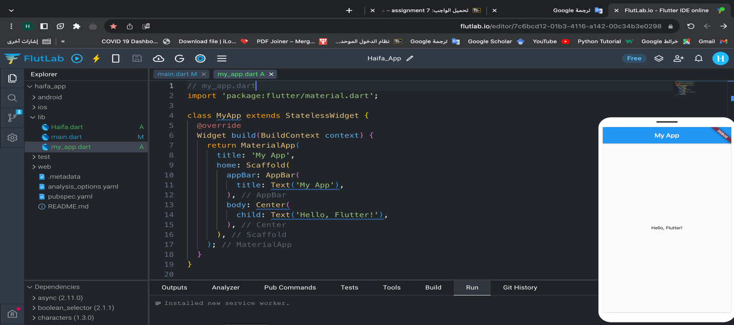

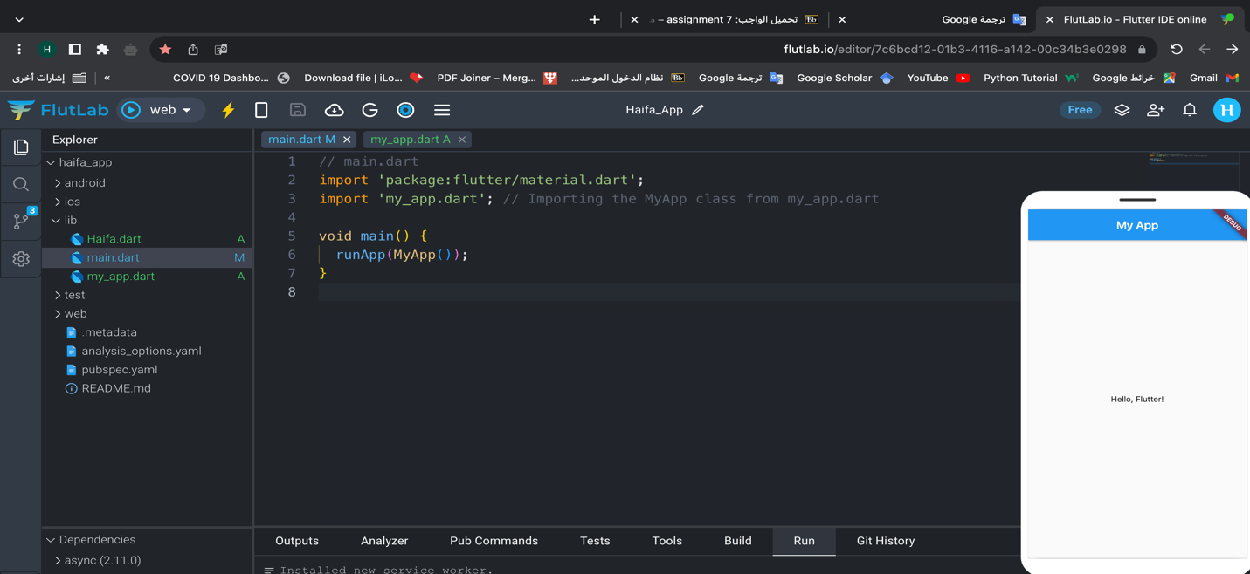

* Write the code to generate the following snapshot

